noodlebox

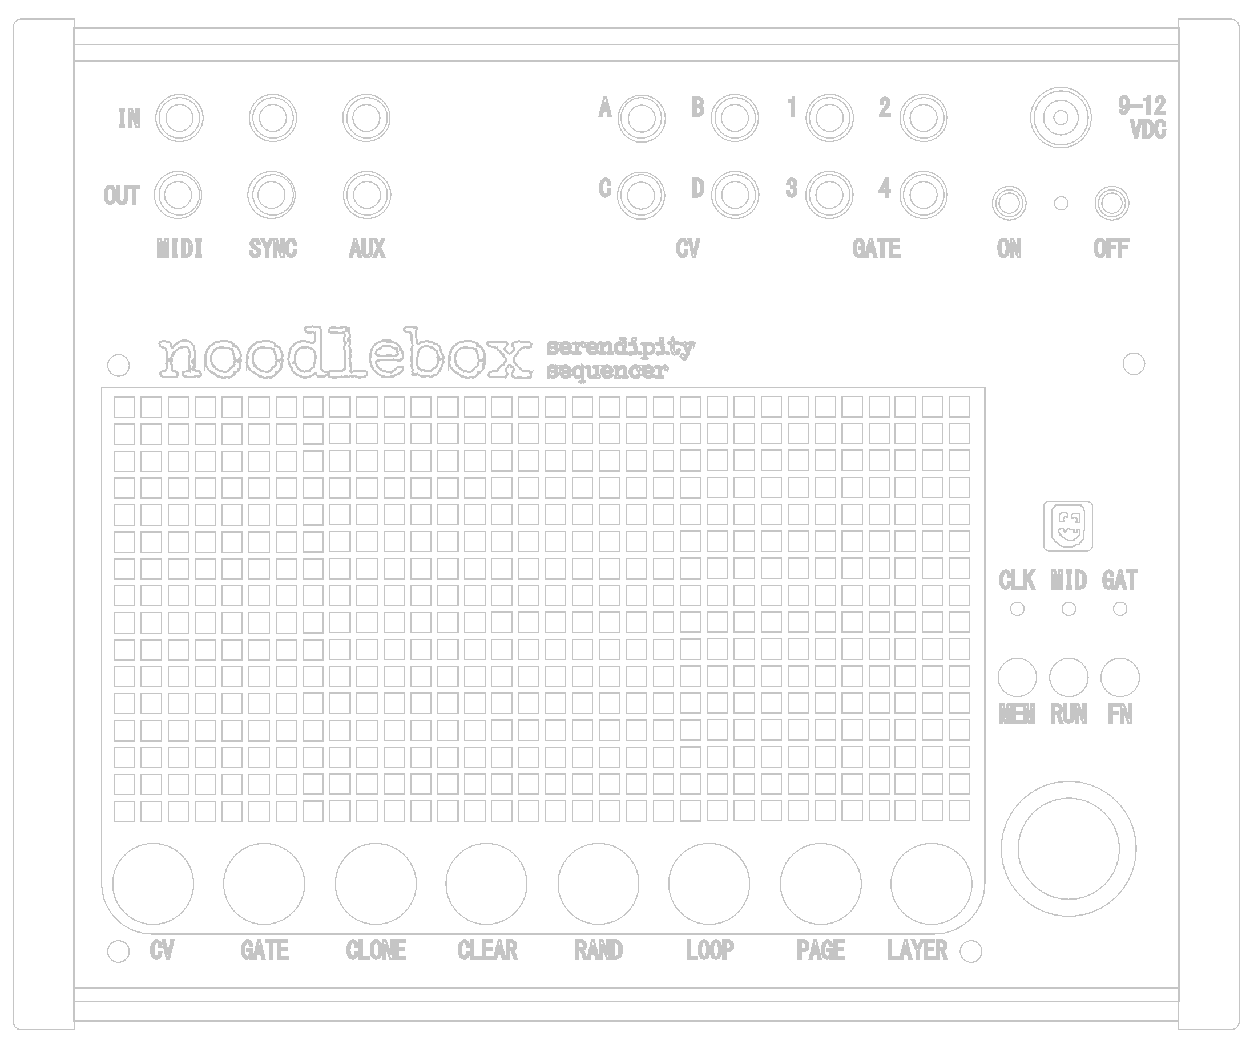

**Thank you for your purchase of a Sixty Four Pixels Noodlebox…** We’ve been working on this for a while and we’re very excited to finally have it in the hands of lovely users like yourself!

Get your new Noodlebox up and running by plugging the included power supply into a mains outlet, then into the power socket to the top right of the noodlebox front panel, making sure it’s plugged fully in.

Hold the ON button for 3-4 seconds to power up the Noodlebox (always power it off by holding the OFF button)

The included quick reference card shows all the command keys and menu options that you can use to control the Noodlebox, however you will definitely want to read the full user guide at **six4pix.com/noodle**

If you have any problems getting set up, or using your Noodlebox please get in touch with us at **sixtyfourpixels@gmail.com**

Cheers!  
Jason

